Day 2 : Advance R programming
Session 5: Graphing
  - ggplot2 basics

shape
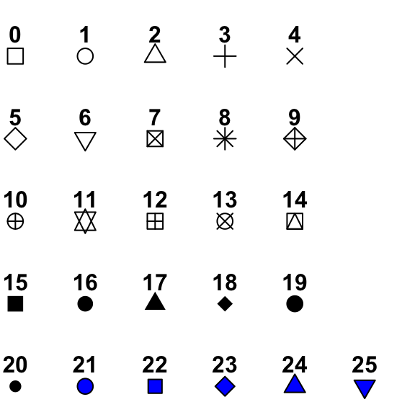
linetype
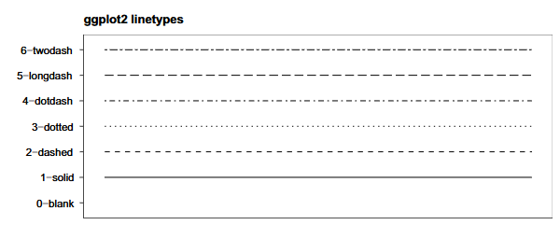
E018-ggplot2_basics.R
#---------------------------------------------------------------------------
# ggplot2 basics
#---------------------------------------------------------------------------
library(ggplot2)
library(mosaicData)

#simple scatter plot
ggplot(data = CPS85, mapping = aes(x = exper, y = wage)) +
geom_point()
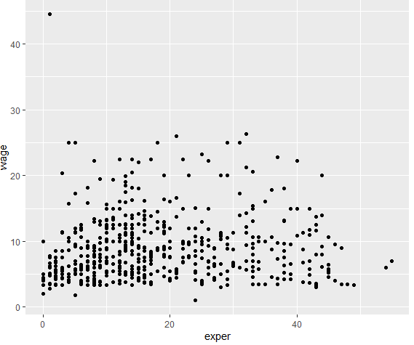

#scatter plot with various attributes
ggplot(data = CPS85, mapping = aes(x = exper, y = wage)) +
geom_point(color = 'blue', shape = 16, alpha = 0.3, size = 2)
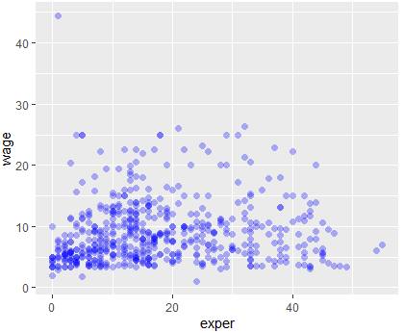

#applying ggplot2 themes
ggplot(data = CPS85, mapping = aes(x = exper, y = wage)) +
geom_point(color = 'blue', shape = 16, alpha = 0.3, size = 2) +
theme_bw()
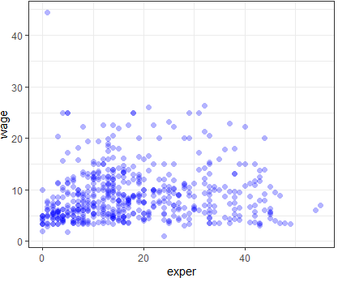

#scatter plot and best fit line
ggplot(data = CPS85, mapping = aes(x = exper, y = wage)) +
geom_point(color = 'blue', shape = 16, alpha = 0.3, size = 2) +
geom_smooth(method = 'lm') +
theme_bw()
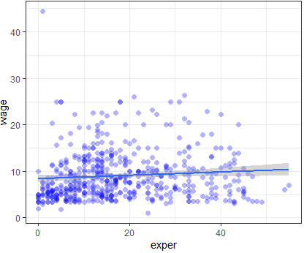

# grouping category variable attribute color
ggplot(data = CPS85, mapping = aes(x = exper, y = wage, color = sex)) +
geom_point(alpha = 0.3, size = 2) +
geom_smooth(method = 'lm', se = FALSE, size = 1.3, linetype = 'longdash') +
theme_bw()
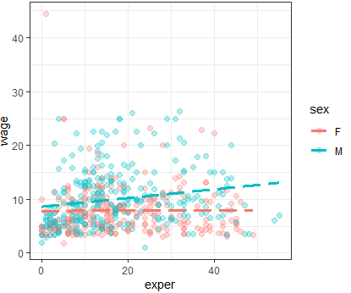
# x-axis and y-axis setting scales
ggplot(data = CPS85, mapping = aes(x = exper, y = wage, color = sex)) +
geom_point(alpha = 0.3, size = 2) +
geom_smooth(method = 'lm', se = FALSE, size = 1.3, linetype = 'longdash') +
scale_x_continuous(breaks = seq(0,70,10)) +
scale_y_continuous(breaks = seq(0,60,5)) +
theme_bw()
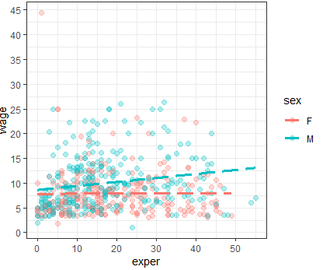
# color manual of grouped category variable
ggplot(data = CPS85, mapping = aes(x = exper, y = wage, color = sex)) +
geom_point(alpha = 0.3, size = 2) +
geom_smooth(method = 'lm', se = FALSE, size = 1.3, linetype = 'longdash') +
scale_x_continuous(breaks = seq(0,70,10)) +
scale_y_continuous(breaks = seq(0,60,5)) +
scale_color_manual(values = c('darkgreen','red')) +
theme_bw()
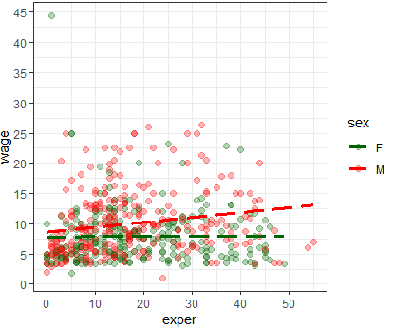
# subplots according to a categorical variable (facet_wrap)
ggplot(data = CPS85, mapping = aes(x = exper, y = wage, color = sex)) +
geom_point(alpha = 0.3, size = 2) +
geom_smooth(method = 'lm', se = FALSE, size = 1.3, linetype = 'longdash') +
scale_x_continuous(breaks = seq(0,70,10)) +
scale_y_continuous(breaks = seq(0,60,5)) +
scale_color_manual(values = c('darkgreen','red')) +
facet_wrap(~sector) +
theme_bw()
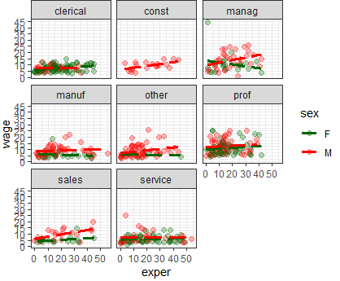
# subplots according to a categorical variable (facet_grid)
ggplot(data = CPS85, mapping = aes(x = exper, y = wage, color = sex)) +
geom_point(alpha = 0.3, size = 2) +
geom_smooth(method = 'lm', se = FALSE, size = 1.3, linetype = 'longdash') +
scale_x_continuous(breaks = seq(0,70,10)) +
scale_y_continuous(breaks = seq(0,60,5)) +
scale_color_manual(values = c('darkgreen','red')) +
facet_grid(union ~ married) +
theme_bw()
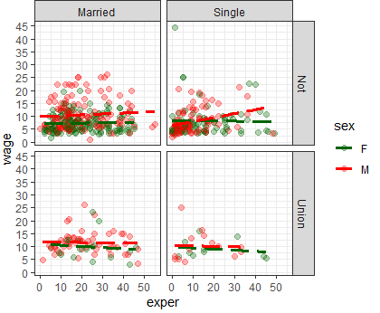
# labels
ggplot(data = CPS85, mapping = aes(x = exper, y = wage, color = sex)) +
geom_point(alpha = 0.3, size = 2) +
geom_smooth(method = 'lm', se = FALSE, size = 1.3, linetype = 'longdash') +
scale_x_continuous(breaks = seq(0,70,10)) +
scale_y_continuous(breaks = seq(0,60,5)) +
scale_color_manual(values = c('darkgreen','red'), labels = c('Male', 'Female')) +
facet_grid(union ~ married) +
labs(title = 'Relationship between wages and experiences',
subtitle = 'Current Population Survey',
caption = "Source: http://mosaic-web.org",
x = "Years of Experience",
y = "Hourly Wage",
color = 'Gender') +
theme_bw()
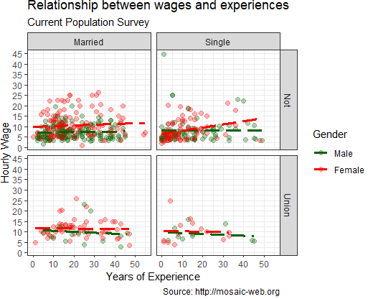

Mapping in individual geom functions, stroing the plot as an R object, and exporting plot
E019-ggplot2_further.R
#---------------------------------------------------------------------------
# ggplot2 further
#---------------------------------------------------------------------------
library(ggplot2)
library(mosaicData)

# mapping color = sex in geom_point instead in ggplot function
ggplot(data = CPS85, mapping = aes(x = exper, y = wage)) +
geom_point(mapping = aes(color = sex), alpha = 0.3, size = 2) +
geom_smooth(method = 'lm') +
theme_bw()
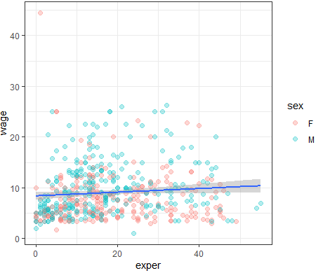
#mapping aes in geom_point and geom_smooth
ggplot(data = CPS85, mapping = aes(x = exper, y = wage)) +
geom_point(mapping = aes(color = sex), alpha = 0.3, size = 2) +
geom_smooth(mapping = aes(linetype = sex, color = sex), method = 'lm') +
theme_bw()
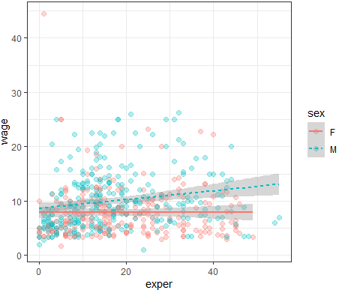

#storing the plot in an object
myplot <- ggplot(data = CPS85, mapping = aes(x = exper, y = wage)) +
geom_point(mapping = aes(color = sex), alpha = 0.3, size = 2) +
geom_smooth(mapping = aes(linetype = sex, color = sex), method = 'lm') +
theme_bw()
myplot

#Saving the plot
ggsave(filename = 'myplot.jpg')
ggsave(filename = 'myplot.pdf')
ggsave(filename = 'myplot.png')

ggsave(filename = 'myplot.jpg', plot = myplot, units = 'cm', width = 20, height = 16)
ggsave(filename = 'myplot.pdf', plot = myplot, units = 'cm', width = 20, height = 16)
ggsave(filename = 'myplot.png', plot = myplot, units = 'cm', width = 20, height = 16)

  - Various types of plots

Bar charts
E020-bar_chart.R
library(ggplot2)
data(Arthritis, package="vcd")

#simple bar chart
table(Arthritis$Improved)
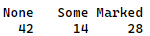

ggplot(Arthritis, aes(x=Improved)) + geom_bar() +
labs(title="Simple Bar chart",
x="Improvement",
y="Frequency") +
theme_bw()
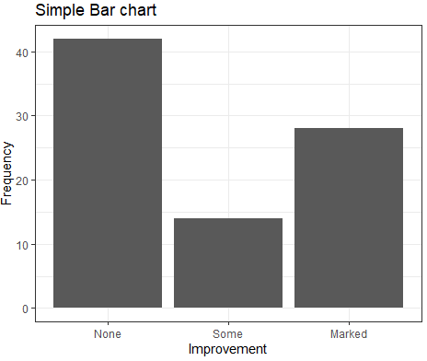

#Horizontal bar chart
ggplot(Arthritis, aes(x=Improved)) + geom_bar() +
labs(title="Simple Bar chart",
x="Improvement",
y="Frequency") +
coord_flip()+
theme_bw()
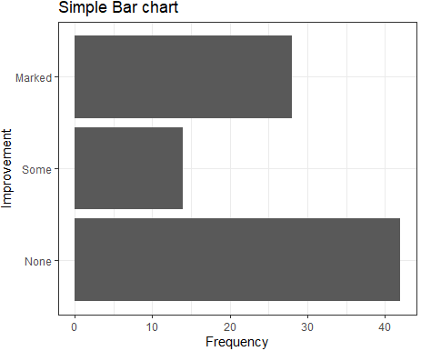

#Stacked bar chart
table(Arthritis$Improved, Arthritis$Treatment)
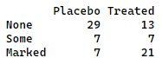

ggplot(Arthritis, aes(x=Treatment, fill = Improved)) +
geom_bar(position = 'stack') +
labs(title="Simple Bar chart",
x="Improvement",
y="Frequency") +
theme_bw()
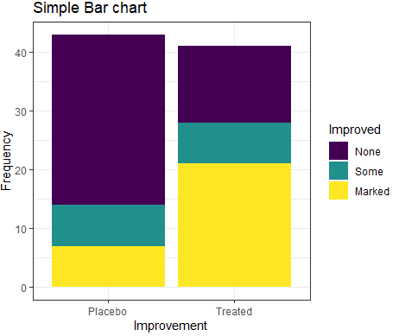

#Grouped bar chart
ggplot(Arthritis, aes(x=Treatment, fill = Improved)) +
geom_bar(position = 'dodge') +
labs(title="Simple Bar chart",
x="Improvement",
y="Frequency") +
theme_bw()
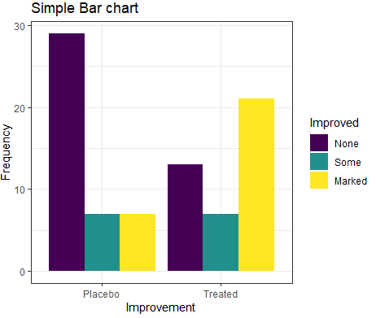

#Filled bar chart
ggplot(Arthritis, aes(x=Treatment, fill = Improved)) +
geom_bar(position = 'fill') +
labs(title="Simple Bar chart",
x="Improvement",
y="Proportion") +
theme_bw()
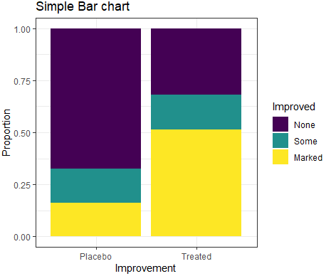

#managing congested labels
ggplot(mpg, aes(x=model)) +
geom_bar() #produce congested labels
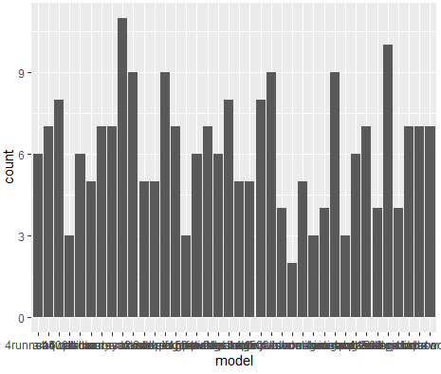
ggplot(mpg, aes(x=model)) +
geom_bar() +
theme(axis.text.x = element_text(angle = 90, hjust = 1))
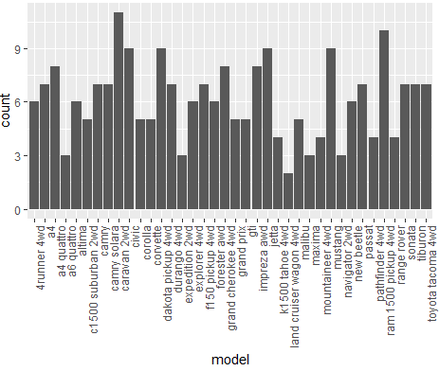
#OR
ggplot(mpg, aes(x=model)) +
geom_bar() +
coord_flip()
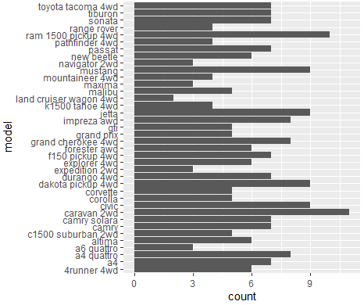

Pie charts
E021-pie_chart.R
#*-----------------------------------------------
#* Pie Chart using inbuilt package graphics
#*-----------------------------------------------
pie(x = c(3,7,9,1,2),
labels = c("A","B","C","D","E"))
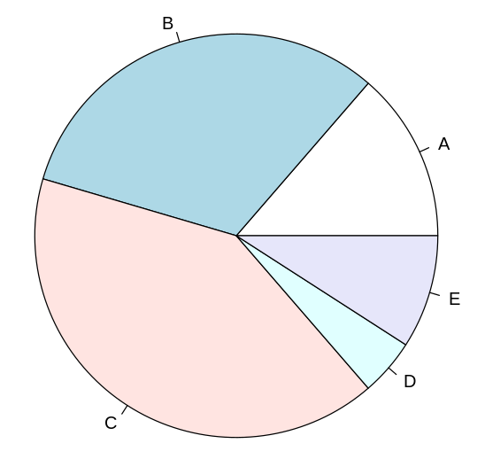
#*-----------------------------------------------
#* Pie Chart using package ggpie
#*-----------------------------------------------

if(!require(remotes)) install.packages("remotes")
remotes::install_github("rkabacoff/ggpie")

library(ggplot2)
library(ggpie)

#simple pie chart
ggpie(mpg, class)
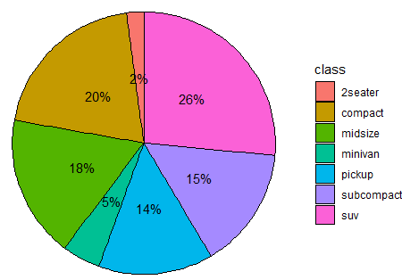

# no legend and offset of labels from the pie chart
ggpie(mpg, class, legend=FALSE, offset=1.3,
title="Automobiles by Car Class")
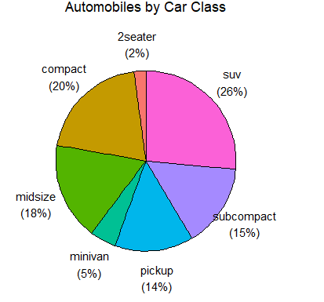

# group wise pie charts
ggpie(mpg, class, year,
legend=FALSE, offset=1.3, title="Car Class by Year")
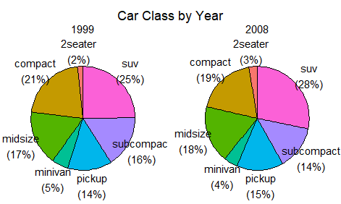

Histograms
E022-histogram.R
library(ggplot2)
library(dplyr)
data(mpg)

#Simple histogram
ggplot(mpg, aes(x=cty)) +
geom_histogram() +
theme_bw()
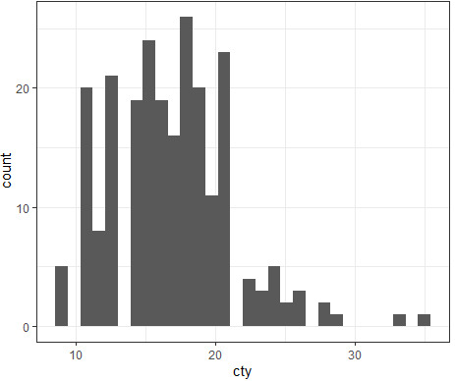

#Colored histogram with 20 bins
ggplot(mpg, aes(x=hwy)) +
geom_histogram(bins=20, fill="red", color = 'black') +
theme_bw()
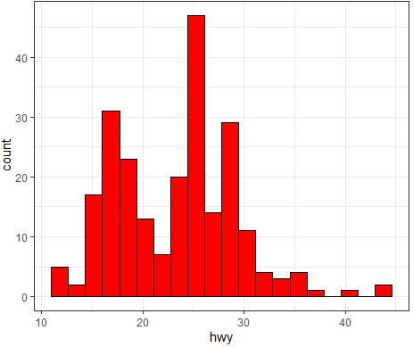
#Histogram with density cruve
ggplot(mpg, aes(x=hwy, y = ..density..)) +
geom_histogram(bins=20, fill="red", color = 'black') +
geom_density(color = 'blue', size = 1.5) +
theme_bw()
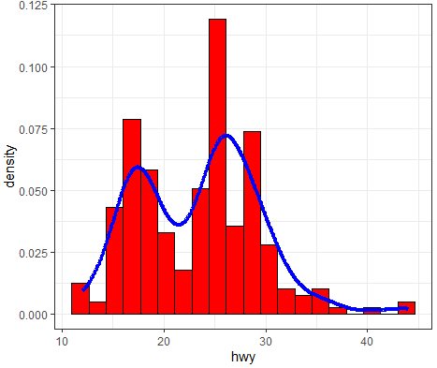

Box plots
A box-and-whiskers plot describes the distribution of a continuous variable by plotting its five-number summary: the minimum, lower quartile (25th percentile), median (50th percentile), upper quartile (75th percentile), and maximum. It can also display observations that may be outliers (values outside the range of Q3 + 1.5 × IQR to Q1 - 1.5 × IQR, where IQR is the interquartile range (Q3 – Q1) defined as the upper quartile minus the lower quartile).
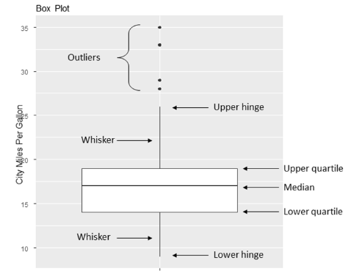
E023-boxplot.R
library(ggplot2)

ggplot(mpg, aes(x="", y=cty)) +
geom_boxplot() +
theme_bw()
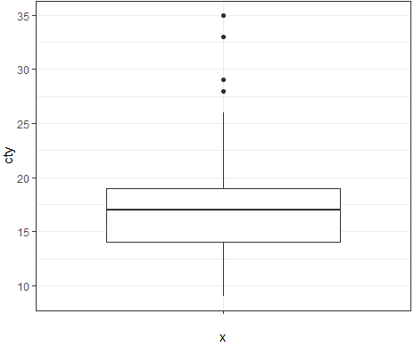
ggplot(mpg, aes(x=factor(cyl), y=cty, fill=factor(year))) +
geom_boxplot() +
scale_fill_manual(values=c("gold", "green")) +
labs(x="Number of Cylinders",
y="Miles Per Gallon",
title="City Mileage by # Cylinders and Year",
fill = "year")
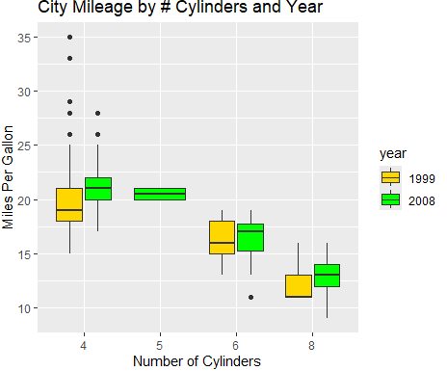

Line plots
E024-line_plot.R
library(ggplot2)
library(dplyr)

wb_energy <- read.csv('data/006-wb_energy.csv')
df <- wb_energy %>% filter(country %in% c('Nepal', 'India', 'Bangladesh', 'Pakistan'))

ggplot(data = df, mapping = aes(x = year, y = ele_total, color = country, linetype = country )) +
geom_line(size = 1.3) +
labs(y = '% of population with access to electricity') +
theme_bw() +
theme(legend.position = 'bottom') +
scale_x_continuous(breaks = seq(1990,2020,2)) +
scale_y_continuous(breaks = seq(0,100,10))
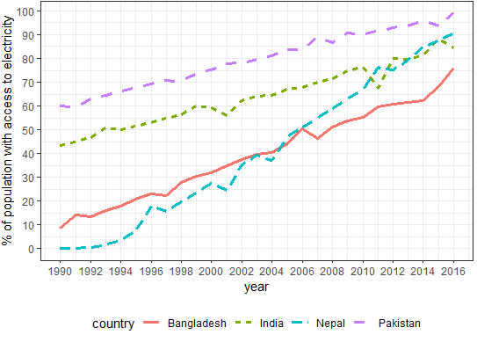

Session 6: R programming
  - Conditional execution
E025-conditional_execution.R
age <- 61

if (age <= 20) {
print('Teen')
} else if (age <=60) {
print('Adult')
} else {
print('Old')
}

  - User-written functions
E026-user_written_function.R
age_classify <- function(age) {
if (age <= 20) {
age_type <- 'Teen'
} else if (age <=60) {
age_type <- 'Adult'
} else {
age_type <- 'Old'
}
return(age_type)
}

age_classify(15)
age_classify(35)
age_classify(85)

  - Looping
E027-looping.R
#-------------------------------------
# For loop
#-------------------------------------
#finding the sum of squares of 1,2,3,4,5
x <- 0
for (i in c(1,2,3,4,5)) {
x <- x + i^2
}
print(x)

#finding the sum of 1 to 100
x <- 0
for (i in 1:100) {
x <- x + i
}
print(x)

#finding the sum of odd numbers from 1 to 100
x <- 0
for (i in 1:100) {
if (i %% 2 == 1) {
x <- x + i
}
}
print(x)

#-------------------------------------
# While loop
#-------------------------------------

#finding the sum of 1 to 100
x <- 0
i <- 0
while (i <= 100) {
x <- x + i
i <- i + 1
}
print(x)

#finding the sum of odd numbers from 1 to 100
x <- 0
i <- 0
while (i <= 100) {
if (i %% 2 == 1) {
x <- x + i
}
i <- i + 1
}
print(x)

Task 5:
Suppose there is no built-in function in R to calculate mean and standard deviation. Write a user defined functions func_mean and func_sd to calculate mean and standard deviation of a given vector.

vec <- c(3,5,2,3,4,2,5,6,7)
mean(vec) # 4.111111
sd(vec) # 1.763834

func_mean <- function(vv) {
x <- 0
count <- 0
for (i in vv) {
x <- x + i
count <- count + 1
}
x_bar <- x/count
return(x_bar)
}

func_sd <- function(vv) {
x_bar <- func_mean(vv)
x <- 0
count <- 0
for (i in vv) {
x <- x + (x_bar - i)^2
count <- count + 1
}
x_sd <- (x/(count-1))^(1/2)
return(x_sd)
}

func_mean(vec)
func_sd(vec)

Session 7: Cross tabulation
  - Frequency tables
E032-frequency_contingency_tables.R
Arthritis <- vcd::Arthritis

#simple frequency table
mytable <- table(Arthritis$Improved)
mytable
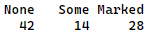

#proportion table
prop.table(mytable)
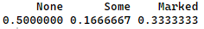

prop.table(mytable)*100 #in percentage
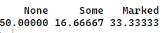

#-------------------------------------
# Two-way table
#-------------------------------------
mytable <- xtabs(~ Treatment + Improved, data=Arthritis)
mytable
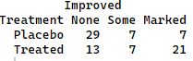

#calculating sub-total horizontally
margin.table(mytable, 1) # 1 here refers 1st variable i.e. Treatment
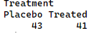

#proportion table based on horizontal sub-total
prop.table(mytable, 1) * 100
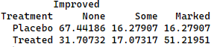

# ***********************************************

#calculating sub-total vertically
margin.table(mytable, 2) # 2 here refers 2nd variable i.e. Improved
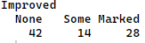

#proportion table based on vertical sub-total
prop.table(mytable, 2) * 100
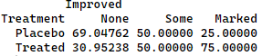

#------------------------------------------------
# Two-way table (add sub-totals and grand totals)
#------------------------------------------------
addmargins(mytable)
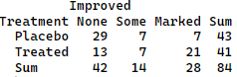

addmargins(prop.table(mytable)) * 100
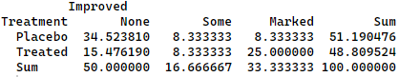

#proportion addmargins horizontally
addmargins(prop.table(mytable, 1), 2) * 100
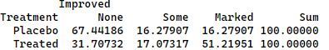

#proportion addmargins vertically
addmargins(prop.table(mytable, 2), 1) * 100
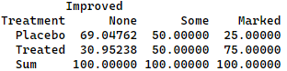

#------------------------------------------------
# Multidimensional table
#------------------------------------------------
mytable <- xtabs(~ Treatment + Sex + Improved, data=Arthritis)
mytable
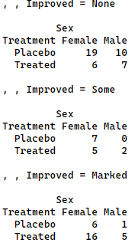

#frequency table
ftable(mytable)
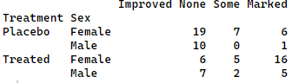

#frequency table defining column variables
ftable(mytable, col.vars = c('Sex','Improved'))
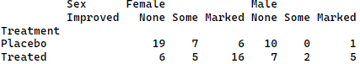

#proportion table
prop.table(ftable(mytable, col.vars = c('Sex','Improved'))) * 100
